- Surds
1. Given that 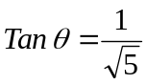and is an acute angle, find without using tables or calculators, Sin (90 - ), leaving your answer in simplified surd form. (2mks)
2. Given that 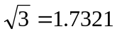, express in surd form, rationalize the denominator and then find the value of the expression below to 5 significant figures without using the calculator. (3mks)
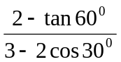
3. Simplify 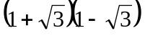and hence evaluate 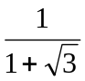 to 3 significant figures given that 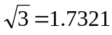. (3mks)
4. Without using mathematical tables or calculators, find the volume of a container whose base is a regular hexagon of side cm and height 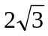cm (4 mks)
5. Simplify; 3 1 leaving the answer in the form a + b c , where a, b and c are
+
rational numbers 7 –2 7
2 + 5
2 - 5

3 + 5
2 + 5

= a + b 5

__

6. Given that:-
Find the values of a and b where a and b are rational numbers

7. If:- 14 - 14 = a 7 + b 2
7 - 12 7 + 2 Find the values of a and b, where a and b are rational numbers *

8. Rationalize the denominator 2- 2 and express your answer in the form of a + c 2
( 2 – 1)³
9. The figure below is a right pyramid with a rectangular base ABCD and vertex V.
15cm
6cm
C
A
B
8cm
D
V
O

O is the centre of the base and M is a point on OV such that OM = ¹/₃ OV, AB = 8 cm, BC = 6 cm
and VA = VB=VD = VC = 15 cm. Find ;
i) The height OV of the pyramid.
ii) The angle between the plane BMC and base ABCD.
10. Find the value of y which satisfies the equation
Log ₁₀ 5 – 2 + log₁₀ (2y + 10) = log₁₀ (y – 4)

11. Simplify the expression √ 3 - √ 2 giving your answer in the for of a + b √ c.
√3 + √2

